A1037-Guatemala-Peten-Mayan Cylinder Vessel-Classic Period-200 – 900 CE

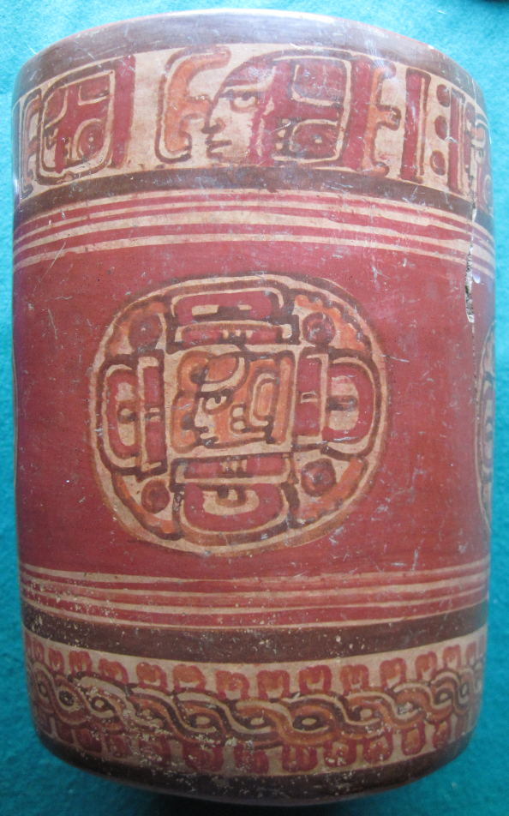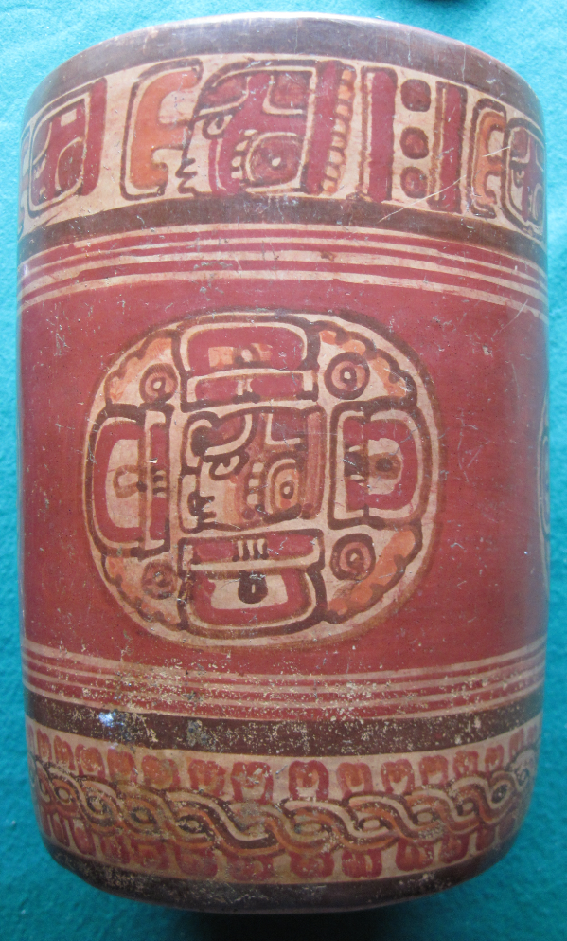

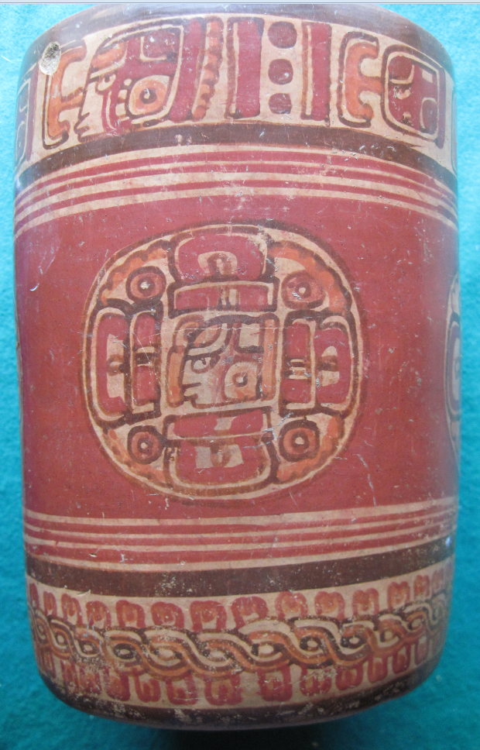 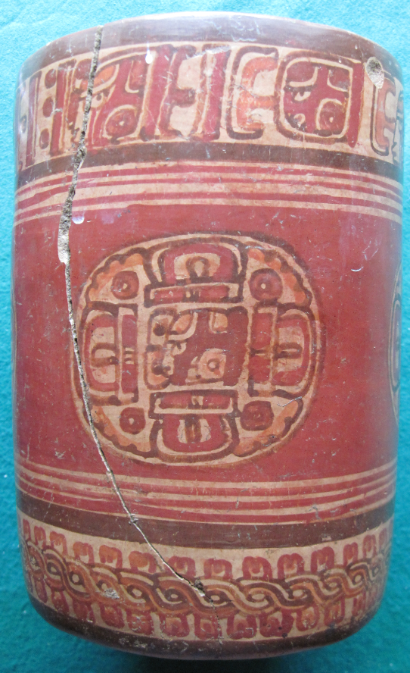

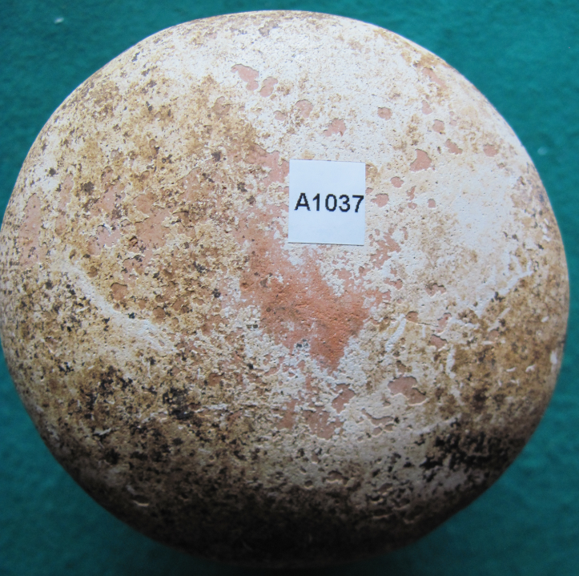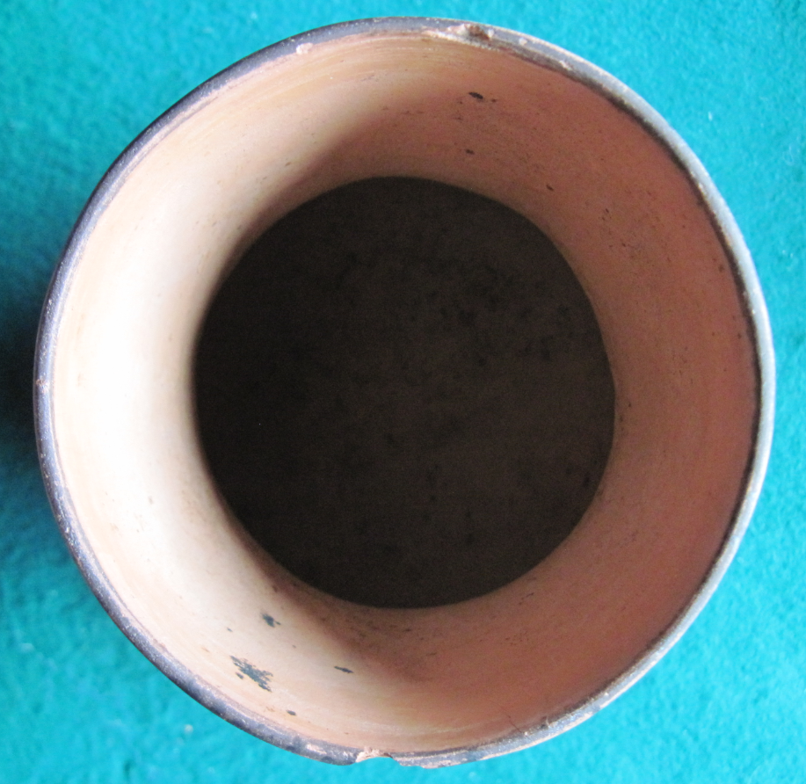

Figs. 106. Guatemala-Peten Basin-Mayan Cylinder Vessel-Classic Period-200 – 900 CE

**Case no.:**

**Accession Number: A1037**

**Formal Label:** Guatemala-Peten-Mayan Cylinder Vessel-Classic Period-200 – 900 CE

**Display Description:**

The rim glyphs on this cylinder vessel present the owner with the description of a new courtly ritual. The circular armorial crests are meant to identify a new Mayan ruler.

“Fire is Born” (Siyaj K'ak') was a Teotihuacan general who defeated Tikal, and he led his forces to defeat Uaxactun in 378 CE. He immediately established a unification of Tikal and Uaxactun that was to dominate the Guatemalan Petén to 550 CE (Schele and Freidel 1990). He installed new kings at Tikal, Uaxactun, Rio Azul, Waka' (El Peru), El Zapote and Bejucal (Martin and Grube 2000).

During this Teotihuacan usurpation, new kings and new rituals and images were introduced by “Fire is Born,” and this cylinder vessel may be evidence that he introduced a new courtly ritual at Uaxactun and presented it to a newly installed king whose insignia is prominently displayed in the four circular armorial crests on this vessel.

**LC Classification:** F 1435.3

**Date or Time Horizon:** ca 378 CE

**Geographical Area:** Uaxactun, Guatemala, Peten department,

**Map, GPS coordinates:** 17.39490 -89.63340;40° 26' 46" N 79° 58' 56" W.

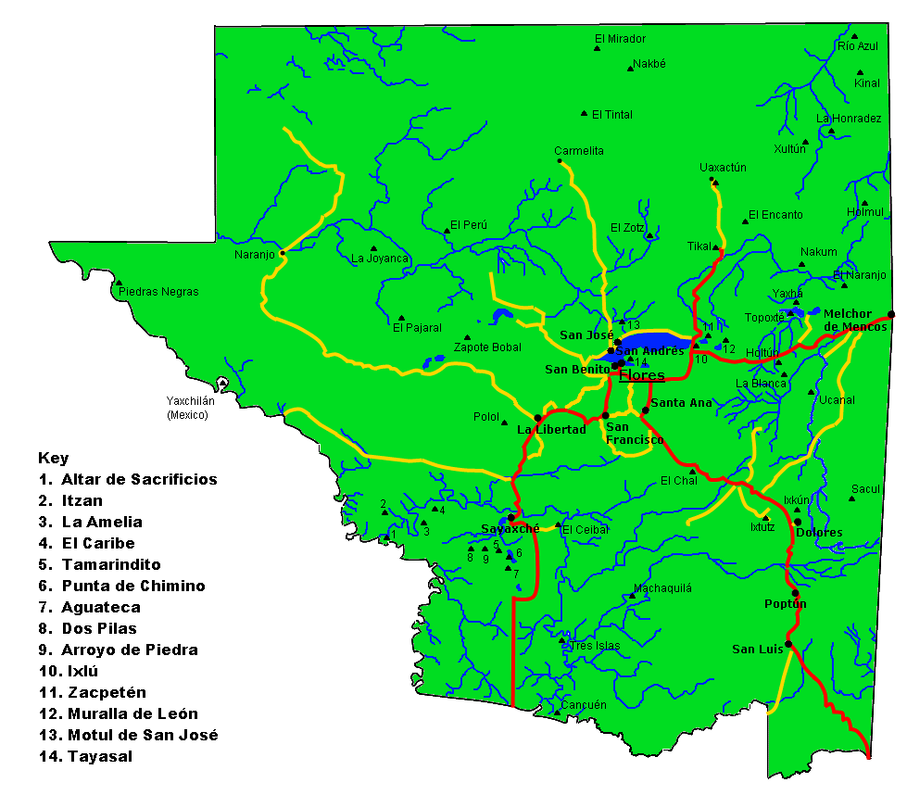

Fig.7. Map of Guatemala-Peten department archaeological sites from <https://upload.wikimedia.org/wikipedia/commons/f/fb/Peten_Map_v3_May_archaeological_sites.gif>

**Cultural Affiliation:** Uaxactun, lowland Mayan, Peten department

**Media: Clay, polychrome colors red, orange, yellow**

**Dimensions:** H 208.05 mm, 8.19 in; Width 153.44 mm, 6.04 in.

**Weight: 1 kg 183 gm; 2 lb 13.5 oz.**

**Condition: original**

**Provenance:** from an old New Jersey estate, ca. 1950.

**Discussion:**

Due to the consolidation of the Peten states especially in the Usumacinta River valley under “Fire is Born,” Petén became the heartland of the Maya Classic Period 378-900 CE. At its height around 750 CE it is estimated that several million people inhabited the Petén Basin and was one of the most densely populated regions of the world at the time. Areas dependent on surface water during this period are estimated to have had ca 2,000 people/km². This explosion of population might have been influenced by the Neo-Atlantic Altithermal Period (NAAP also the Medieval Warm Period) that was responsible for much of the population expansion among Mississippian peoples on the Mississippi River and its tributaries from 750-1250 CE. The inception of the Pacific Climatic Period (PCP) ca. 1250 -1350 CE in the Mississippi River valley drastically reduced the precipitation and the growing season. However, the Peten population is estimated to have dropped by two-thirds in the period 850- 950 CE (Sharer and. Traxler 2006), suggesting that something like the PCP impacted the slash and burn agriculture 300 years earlier than it did in the Mississippi River valley: this may have been La Niña events ca 850-950 CE, in which trade winds intensify from east to west, welling up very cold water on the east, resulting in weather patterns that are the reverse of El Niño. Cooler temperatures and less rainfall occur along the coasts of Central and South America.

Classic Maya sites in the Petén Basin that depended on surface water sources and conducive temperatures for maize agriculture but failed in this period 850-950 CE include:

1. [Usumacinta River](https://en.wikipedia.org/wiki/Usumacinta) valley:

[Uaxactún](https://en.wikipedia.org/wiki/Uaxact%C3%BAn), [Tikal](https://en.wikipedia.org/wiki/Tikal), [Holmul](https://en.wikipedia.org/wiki/Holmul" \o "Holmul), [La Sufricaya](https://en.wikipedia.org/wiki/La_Sufricaya), [Machaquilá](https://en.wikipedia.org/wiki/Machaquil%C3%A1" \o "Machaquilá), [Naranjo](https://en.wikipedia.org/wiki/Naranjo), [Nakum](https://en.wikipedia.org/wiki/Nakum" \o "Nakum), [Piedras Negras](https://en.wikipedia.org/wiki/Piedras_Negras,_Guatemala" \o "Piedras Negras, Guatemala), [Altar de Sacrificios](https://en.wikipedia.org/wiki/Altar_de_Sacrificios)

1. San Pedro Mártir River valley:

Waka' formerly [El Perú](https://en.wikipedia.org/wiki/El_Per%C3%BA)

1. [Petexbatún](https://en.wikipedia.org/wiki/Petexbat%C3%BAn) Lake area:

[Ceibal](https://en.wikipedia.org/wiki/Seibal) and [Aguateca](https://en.wikipedia.org/wiki/Aguateca" \o "Aguateca)

1. [La Pasión River](https://en.wikipedia.org/wiki/Pasi%C3%B3n_River) valley:

[Cancuén](https://en.wikipedia.org/wiki/Cancu%C3%A9n)

1. Lake Yaxha:

[Topoxté](https://en.wikipedia.org/wiki/Topoxt%C3%A9) and [Yaxhá](https://en.wikipedia.org/wiki/Yaxh%C3%A1" \o "Yaxhá)

This sequence of climatic events appears to have paralleled the usurpation of political and religious power. In 378 CE, after the conquest by Siyaj K'ak', and during most of the Early Classic Period, Uaxactun managed to keep élite prerogatives of monument carving, temple erection, and rich burials (Culbert 1990). The present cylinder vessel is an example of this continuity, albeit with innovations of glyptic style. Then an Hiatus Period ensued 554 -711 CE between Early Classic and Late Classic, and Uaxactun experienced a curtailment of new architectural activity and ceramic production, that paralleled the decline of Teotihuacán’s and Tikal’s political and religious power. By mid-Late Classic, ca. 750 CE, Uaxactun showed evidences of a population increase as Peten’s population grew to several million and new construction began of temples, new residential areas, plaza groups, and buildings. Then ca. 850 CE at the end of Late Classic the population of Uaxactun decreased (Evans and Webster 2013), which may have been influenced by La Niña events ca 850-950 CE: the last inscribed monument in Uaxactun was dated in 889 (Foster 2006). By the end of Terminal Classic, ca 950 CE, Uaxactun and Tikal were virtually abandoned (Sullivan and Sagebiel 2003), with a reduced carrying capacity of the mainly maize-producing agricultural fields that were essential for feeding an urban population of several million (Sharer and. Traxler 2006).

**References:**

Culbert, T. P. 1990. "Polities in the northeast Peten, Guatemala." In *Classic Maya Political History: Hieroglyphic and Archaeological Evidence*, edited by T. P. Culbert. Cambridge: Cambridge University Press.

Evans, Susan Toby and David L Webster, eds. 2013. *Archaeology of Ancient Mexico and Central America: An Encyclopedia*. Hoboken: Taylor and Francis.

Foster, Lynn V. 2006. *Handbook to Life in the Ancient Maya World*. New York: Oxford University Press.

Martin, Simon; Nikolai Grube. 2000. Chronicle of the Maya Kings and Queens: Deciphering the *Dynasties of the Ancient Maya*. London and New York: Thames & Hudson.

Scarborough, Vernon L., Fred Valdez, and Nicholas P Dunning. 2003. *Heterarchy, political economy, and the ancient Maya : the Three Rivers Region of the east-central Yucatán Peninsula*. Tucson: University of Arizona Press.

Schele, Linda; David Freidel. 1990. *A Forest of Kings: The Untold Story of the Ancient Maya.* New York: William Morrow.

Sharer, Robert J.; Loa P. Traxler. 2006. *The Ancient Maya* (6th edition). Stanford: Stanford University Press.

Sullivan, L. A. and K. L. Sagebiel 2003. "Changing Political Alliance in the Three Rivers Region." In *Heterarchy, political economy, and the ancient Maya : the Three Rivers Region of the east-central Yucatán Peninsula*, edited by V. L. Scarborough, F. Valdez, and N. P. Dunning. Tucson: University of Arizona Press.